**Demonstrate how to get data from CSV and JSON**

Step-1:

First I open postman

Step-2:

Then I click on run collection

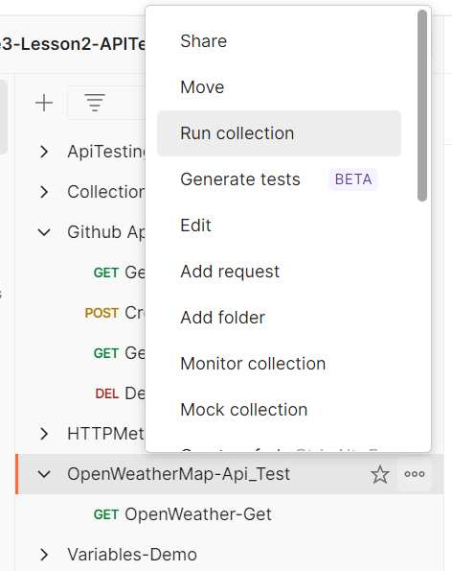

Step-3:

Here I select my csv file and then run it

